**Day 20**

**Sprint 1 Submission**

**Name: Mriganka Patra**

**Emp ID: 2415820**

**Email: Mriganka.Patra@cognizant.com**

Task:

Write and execute manual test cases for SharePoint forms.

|  |  |  |  |  |  |  |
| --- | --- | --- | --- | --- | --- | --- |
| Project Name | Day 20 Sprint  submission | | |  |  |  |
| Client | Flipkart | | |  |  |  |
| Created By | **Name: Mriganka Patra** | | |  |  |  |
| Creation Date | 2025-06-25 | | |  |  |  |
| Approval Date | 22-06-25 | | |  |  |  |
|  |  |  |  |  |  |  |
| **Epic** | **Task** | **User Story ID** | **Features / Title** | **User Story** | **Status** | **Acceptance**  **Criteria** |
|  |  |  |  |  |  |  |
| Employee Onboarding and IT Asset Management Portal | Write and execute manual test cases for SharePoint forms | D001 | Login | As a registered user, I want to login to the website so that I can check the SharePoint forms. | New | System must validate user credentials and allow login if credentials are correct |
| D002 | Field Check | As a user I have to provide all the mandatory fields otherwise the form won’t allow to be submitted. | New | Users have to fill up all mandatory fields to submit the form. |
| D003 | Data Type  Validation | As a user I cannot provide invalid information to the fields in the form. | New | Users can not provide invalid data. |
| D004 | Form  Submission | As a user I must be able to submit the form and the server must keep track of my submitted information. | New | User can submit forms. |
| D005 | Form  Cancellation | As a user I must be able to cancel a form submission if needed and my data should not be recorded in that case. | New | User can cancel forms. |

Manual Test Cases:

**Test Case 1: Form Validation - Required Field Check**

Description: Verify that the form prevents submission when required fields are left blank and displays appropriate error messages.

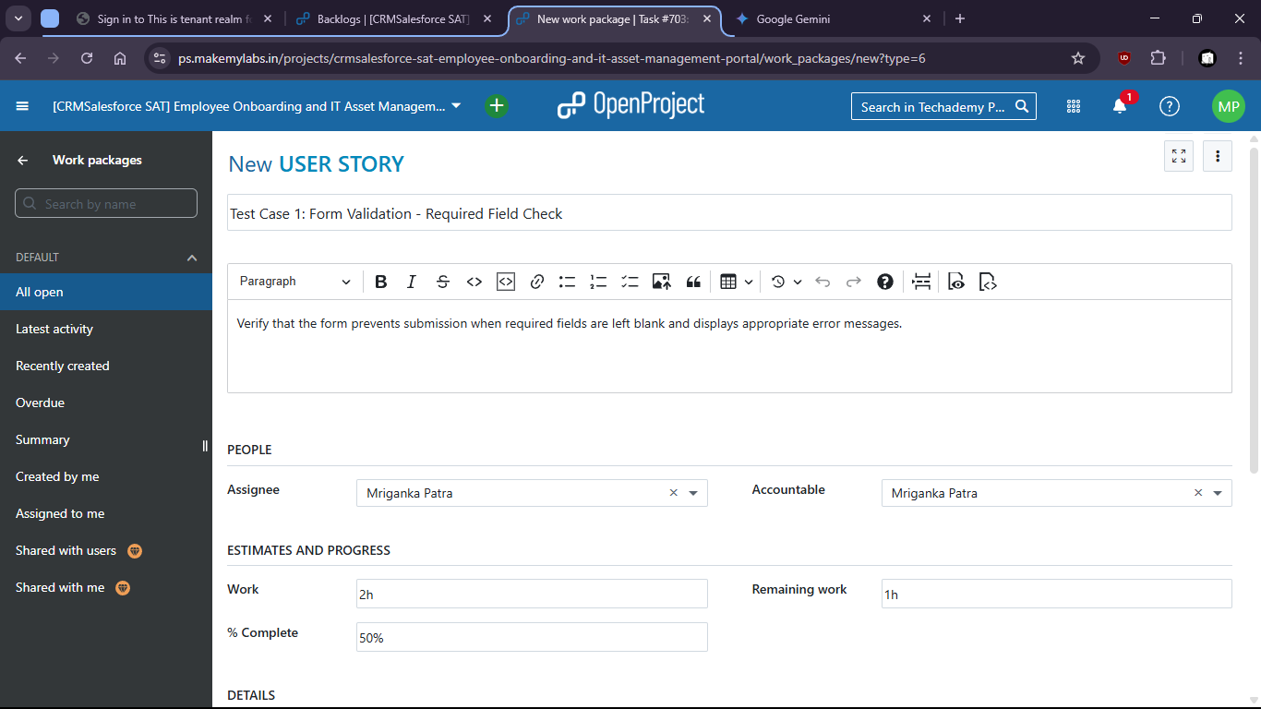

1. Test for the SharePoint form if blank field shows any error.
2. 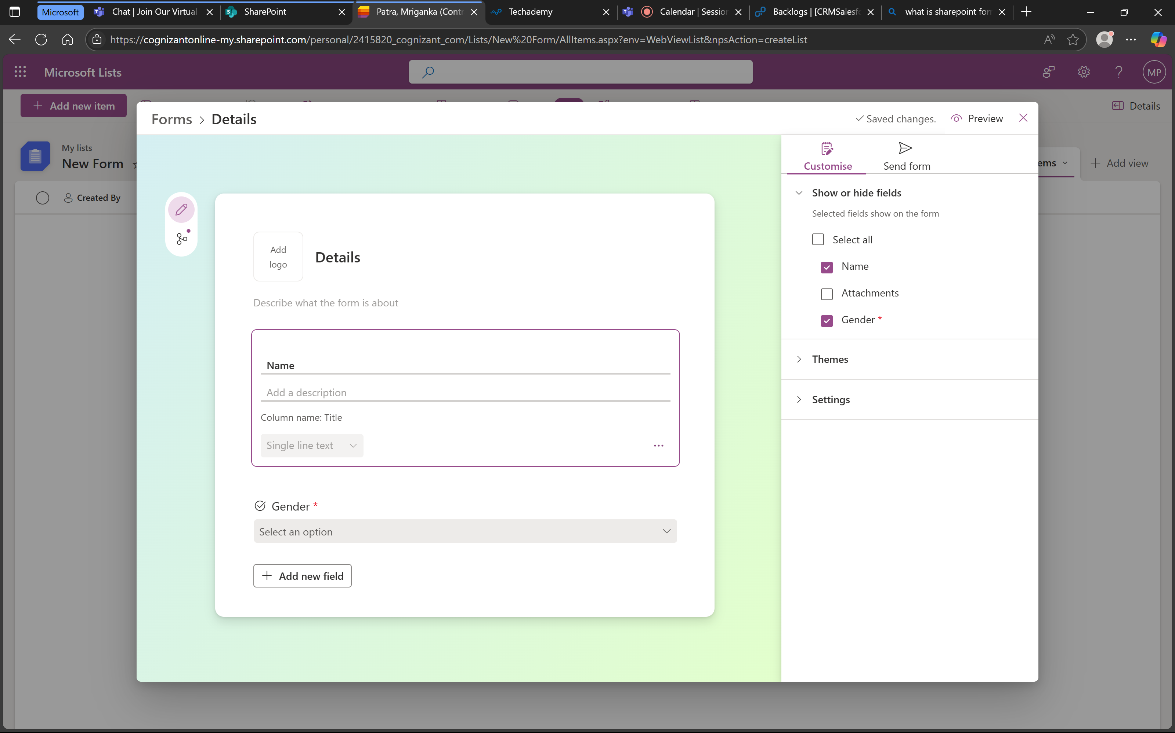

1. When mandatory field gender is not filled it shows error message.

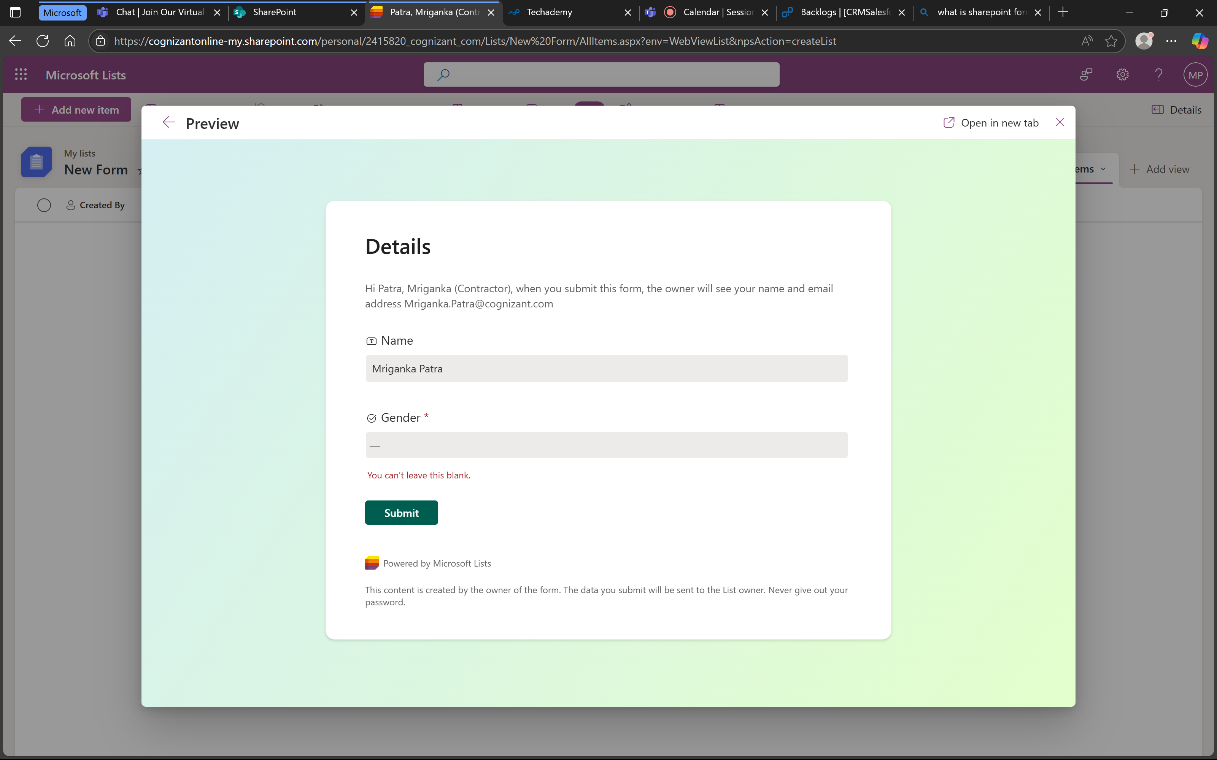

1. Means that the form is working successfully.

**Test Case 2: Data Type Validation - Invalid Input**

Description: Verify that the form correctly validates input for specific data types (e.g., names, gender) and displays error messages for invalid entries.

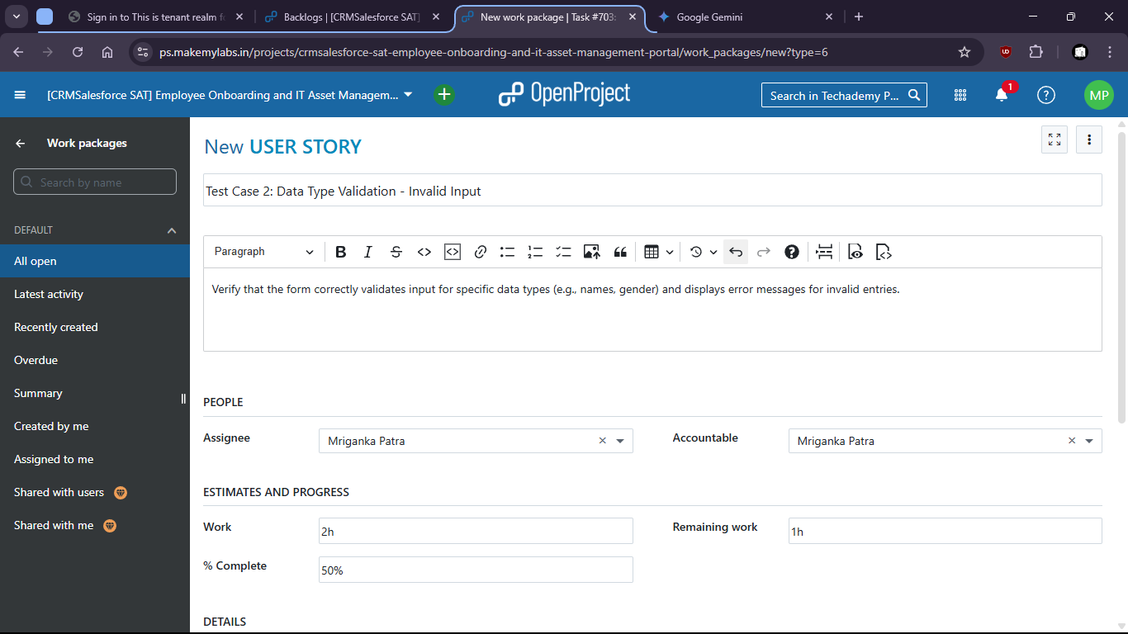

1. There is no option to put invalid data and submit wrong format.
2. Try to put invalid data in the filed like gender

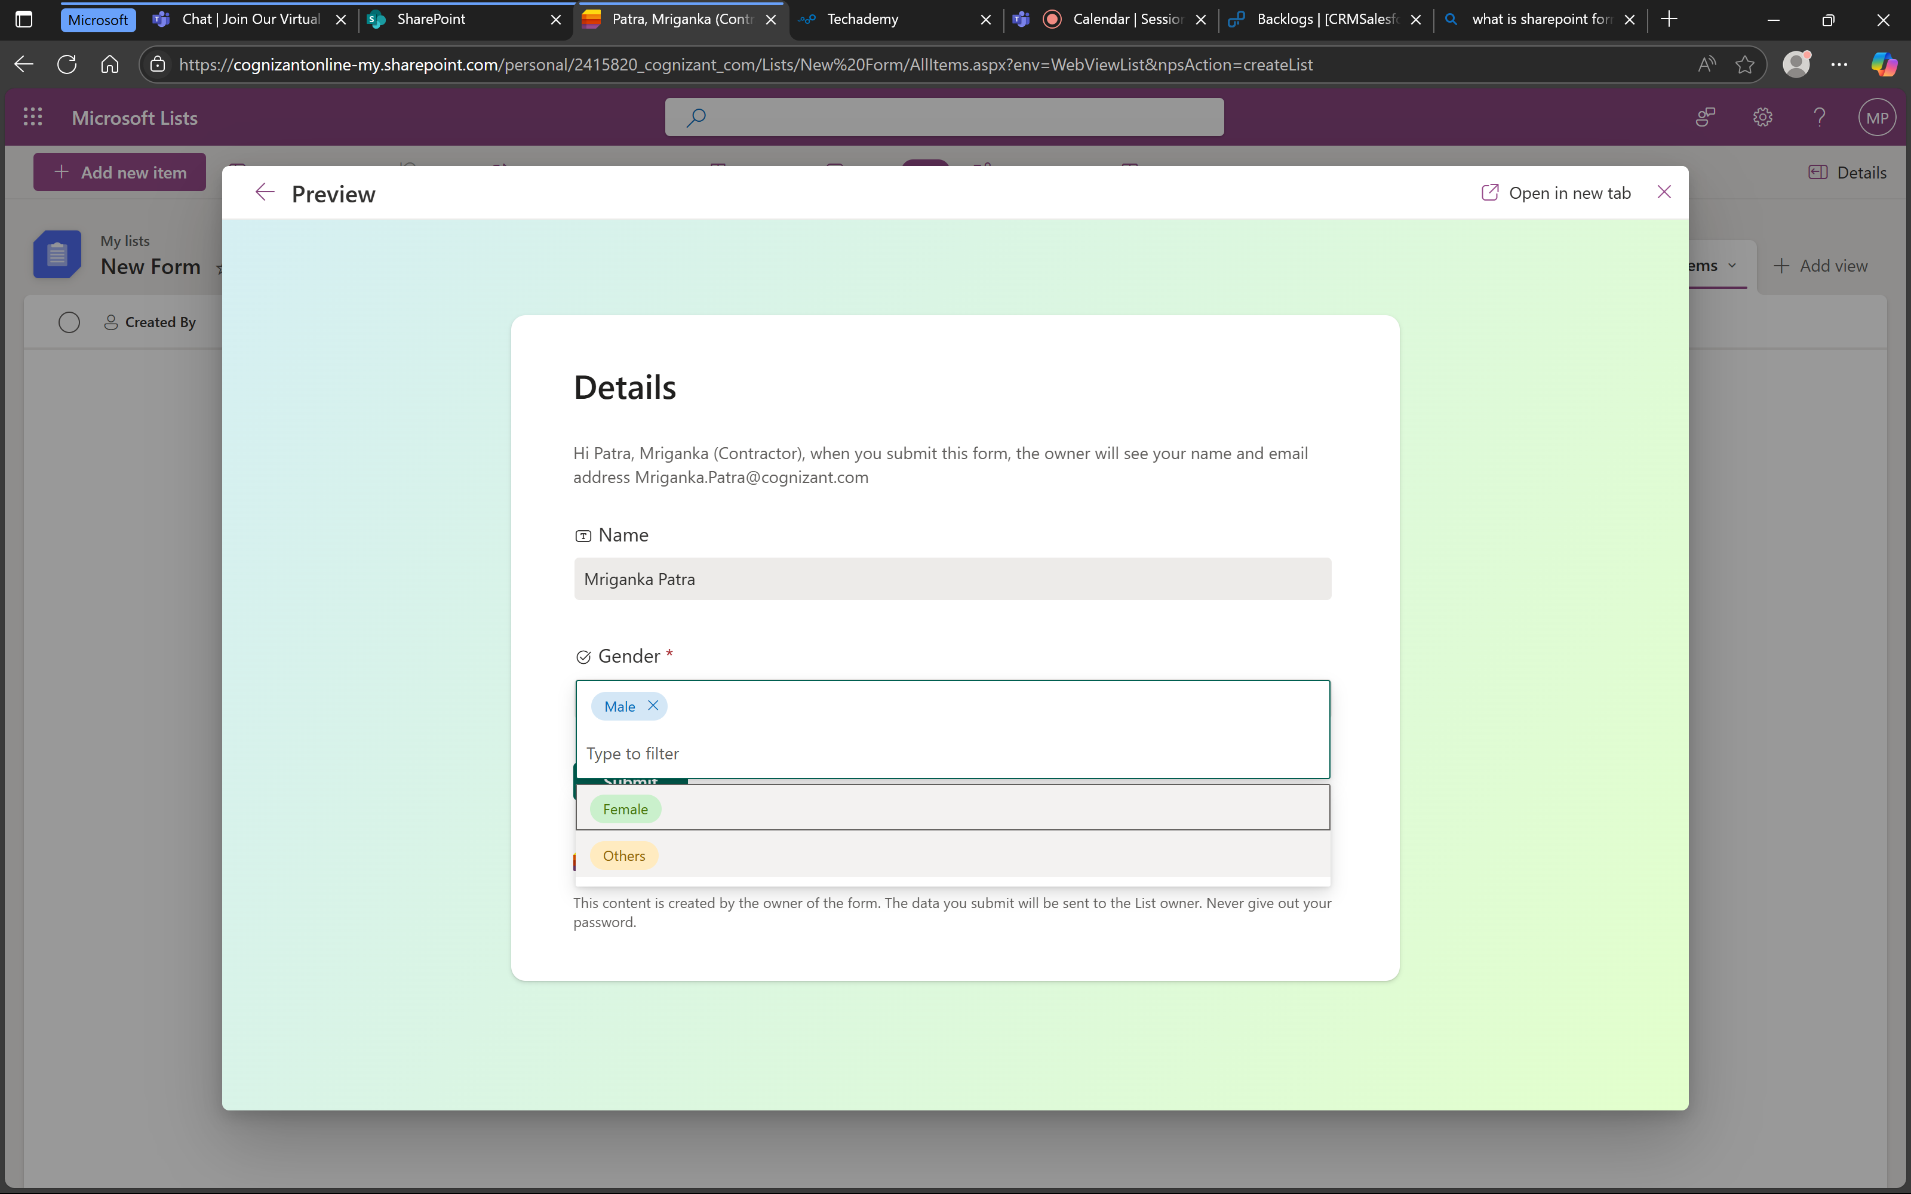

1. There is no option to put invalid data.

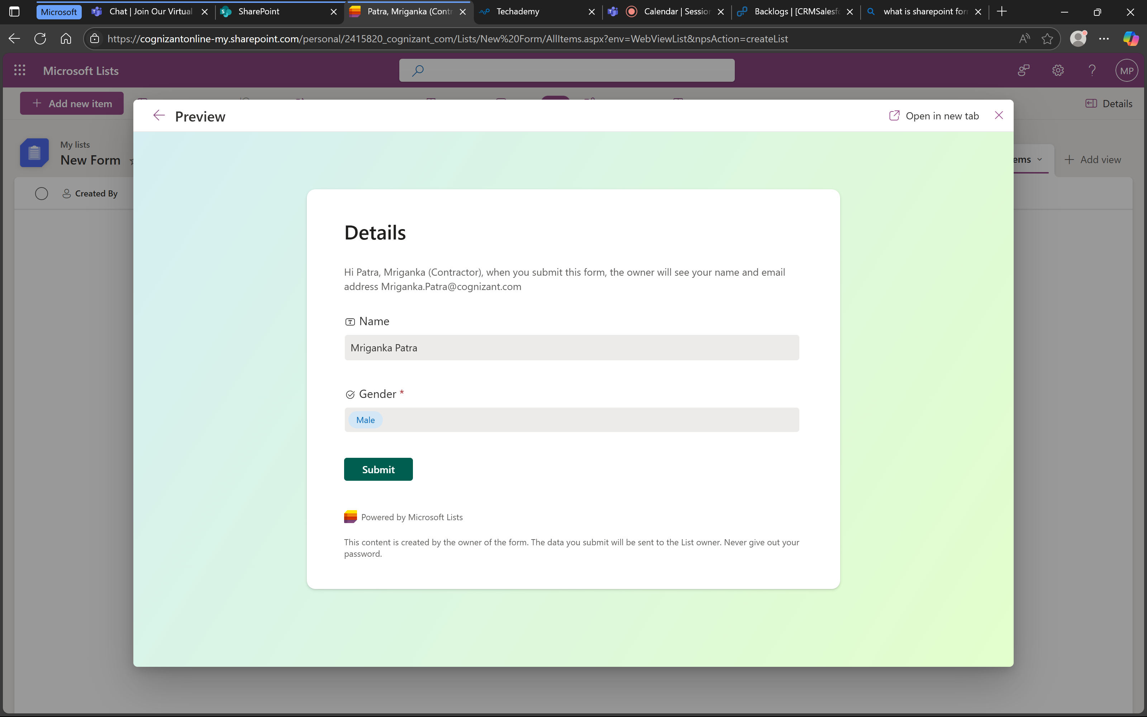

1. That means the test is success and form is working as expected.

**Test Case 3: Form Submission - Successful Submission**

Description: Verify that a new item can be successfully created and saved through the SharePoint form.

1. Check if the form is being submitted successfully.

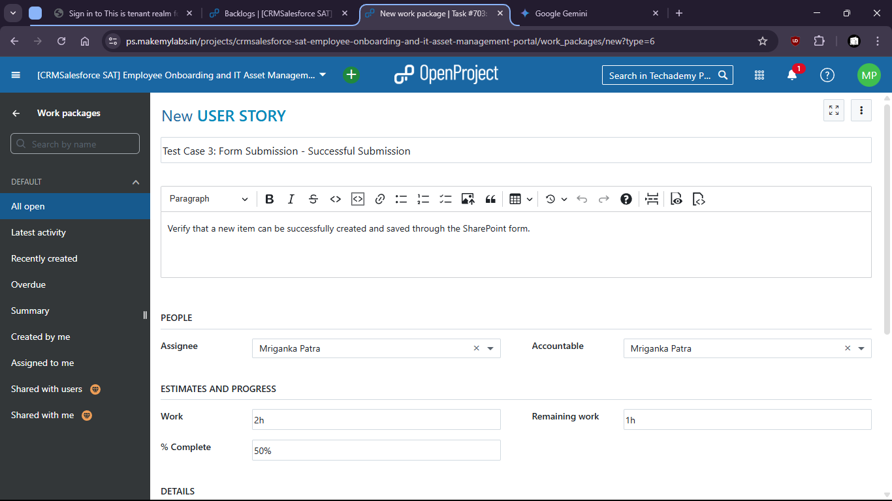

1. Put valid data and submit the form.

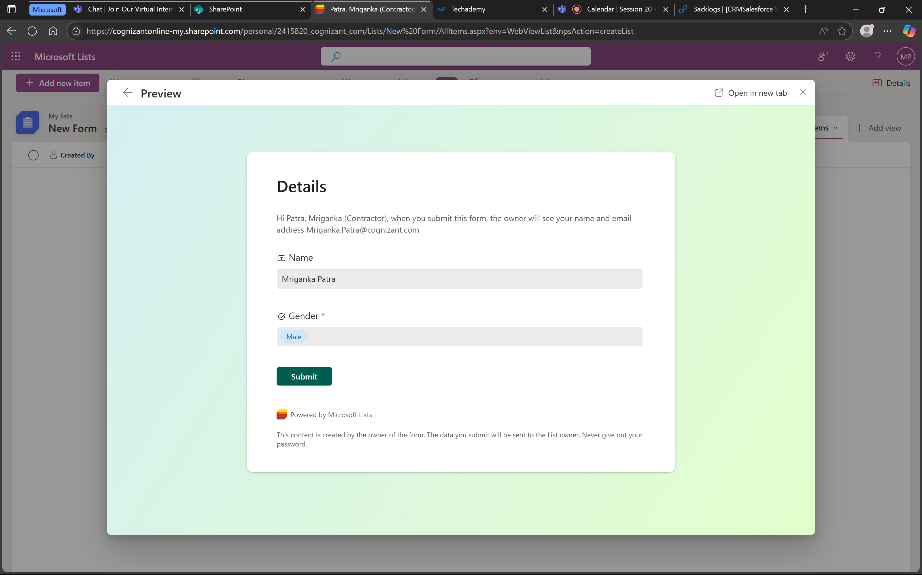

1. Form is submitted.

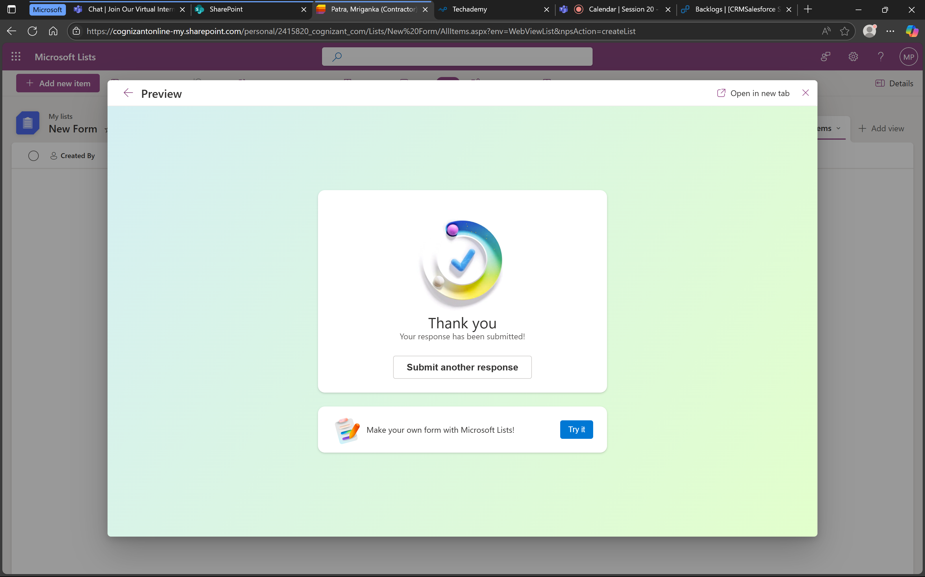

1. Values are also stored successfully.

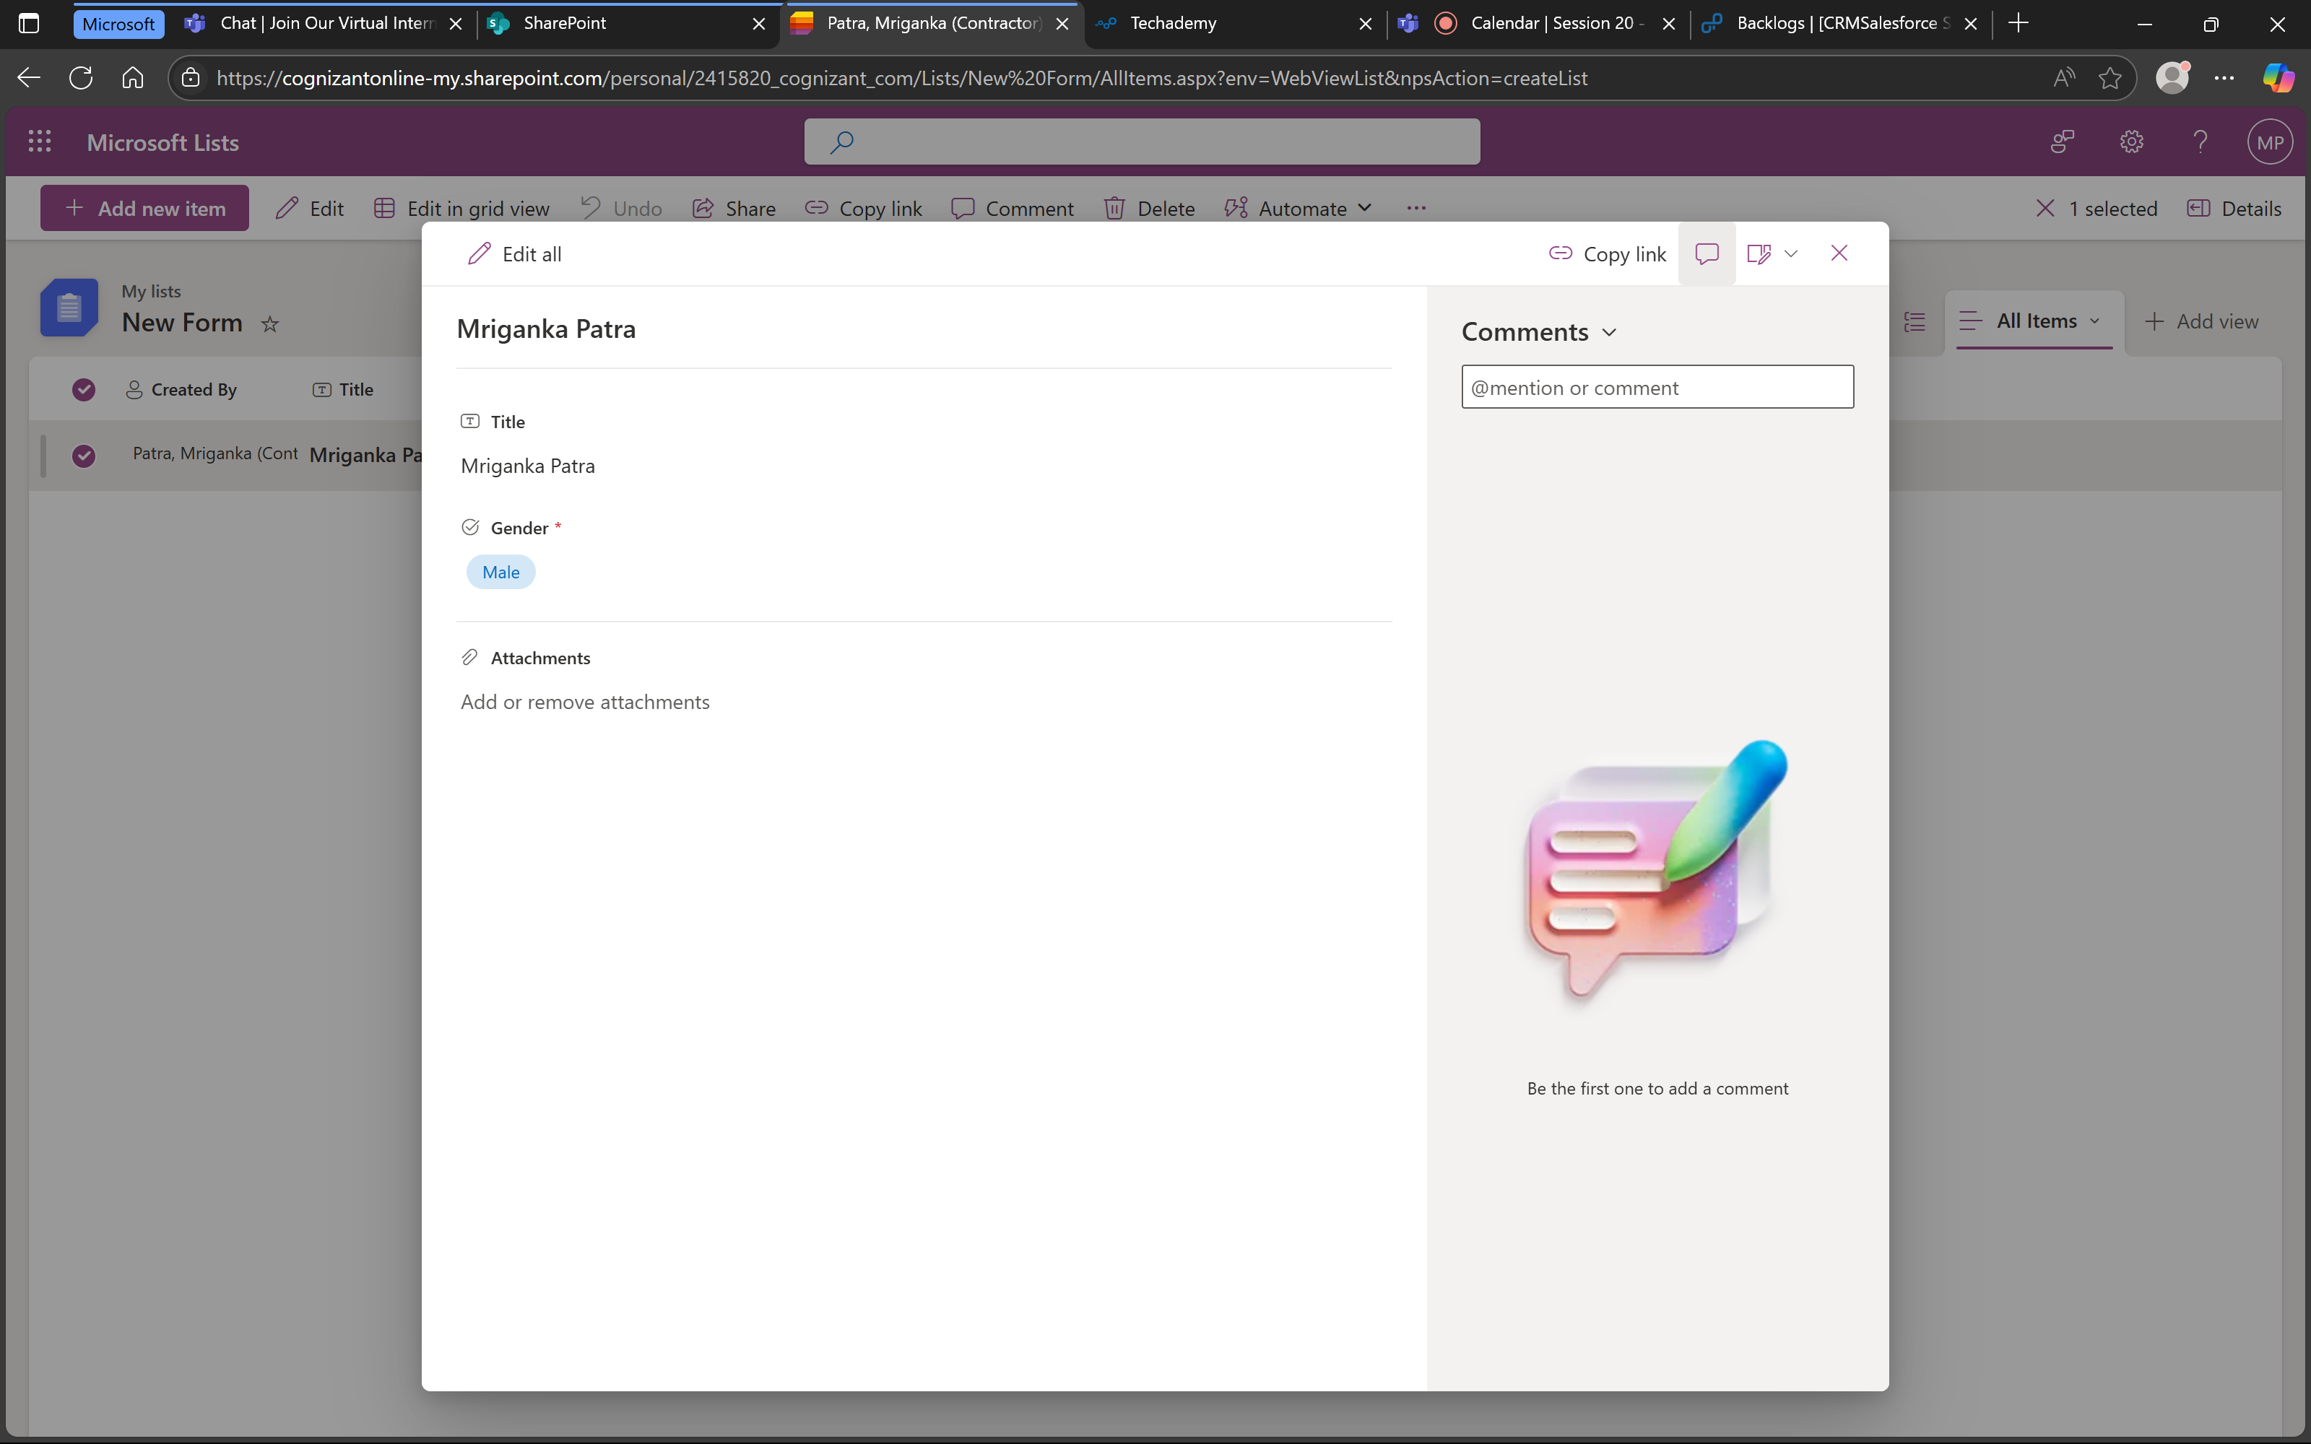

1. That means the form is working successfully.

**Test Case 4: Form Cancellation**

Description: Verify that the form can be cancelled without creating an item.

1. Check if after cancellation the data is being cleared.

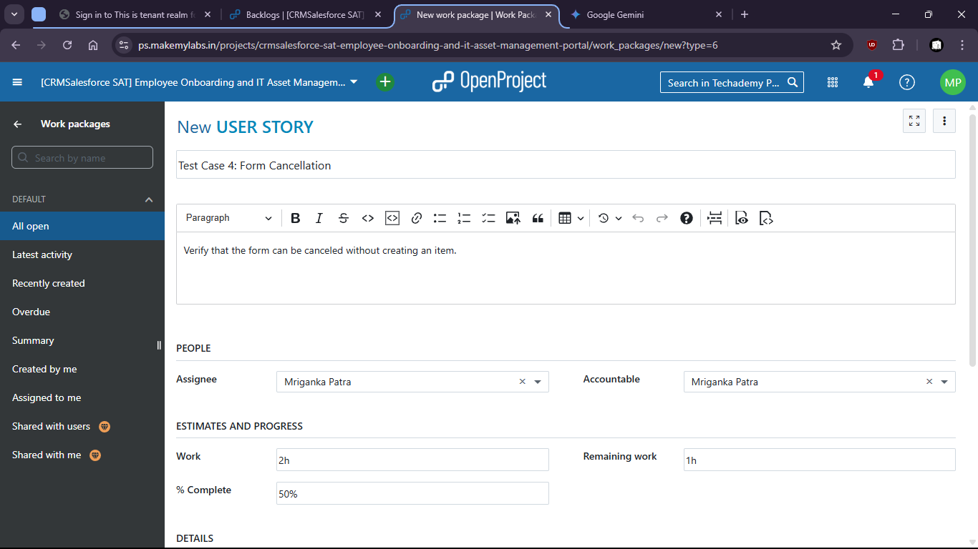

1. Form is filled up

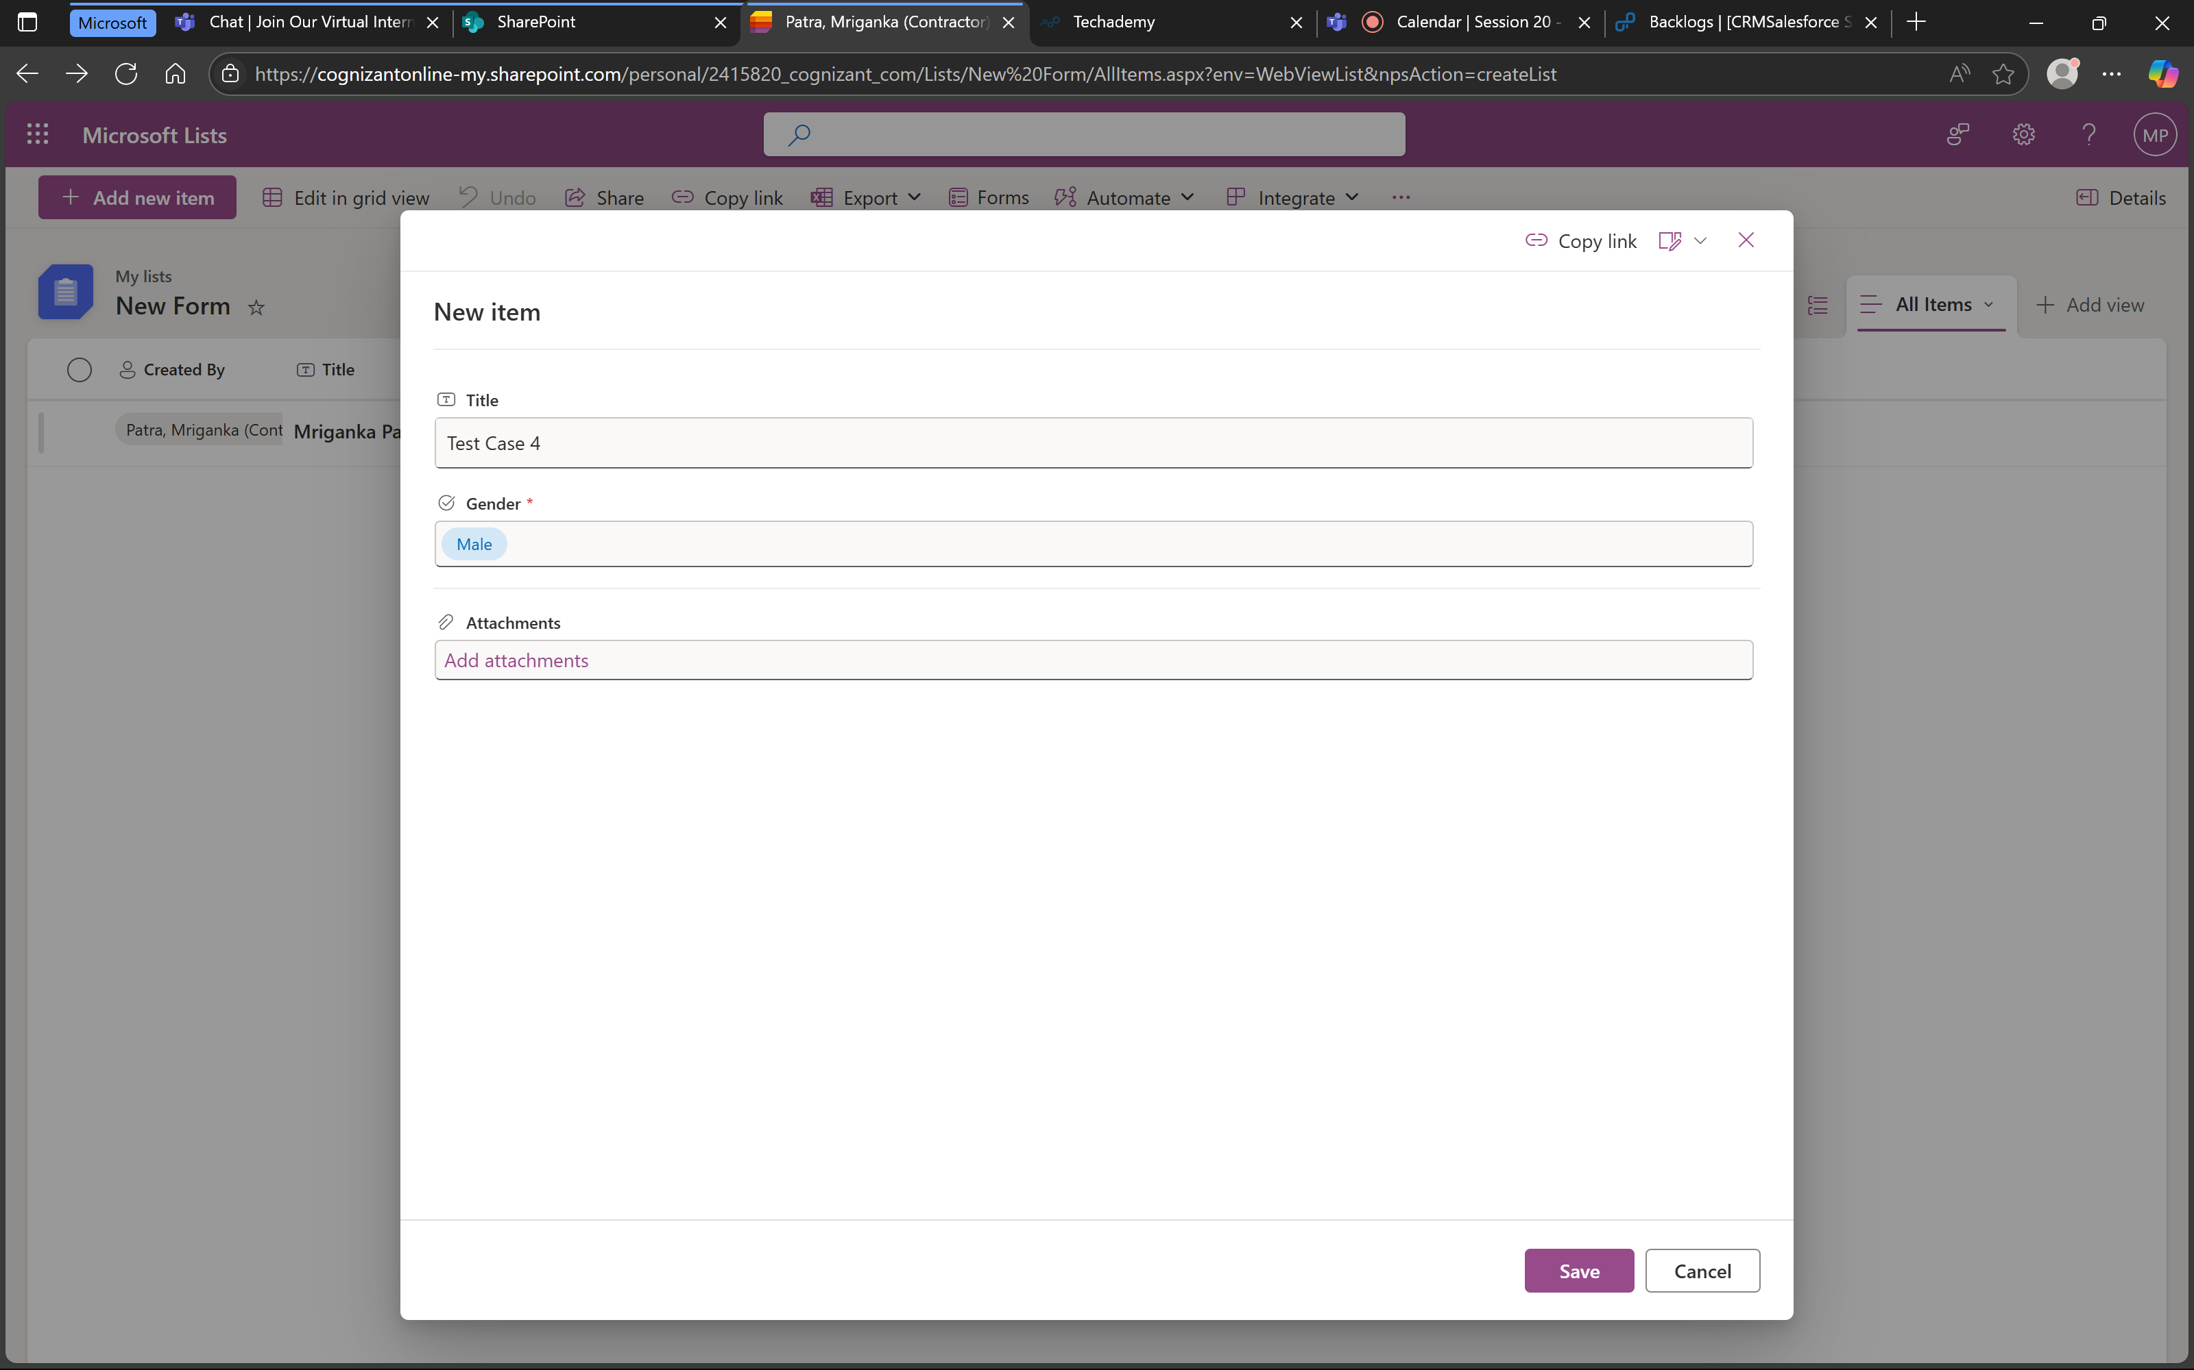

1. Then it is cancelled:

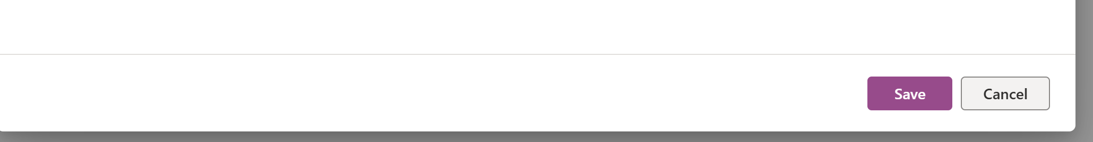

1. We can check that no new form is created

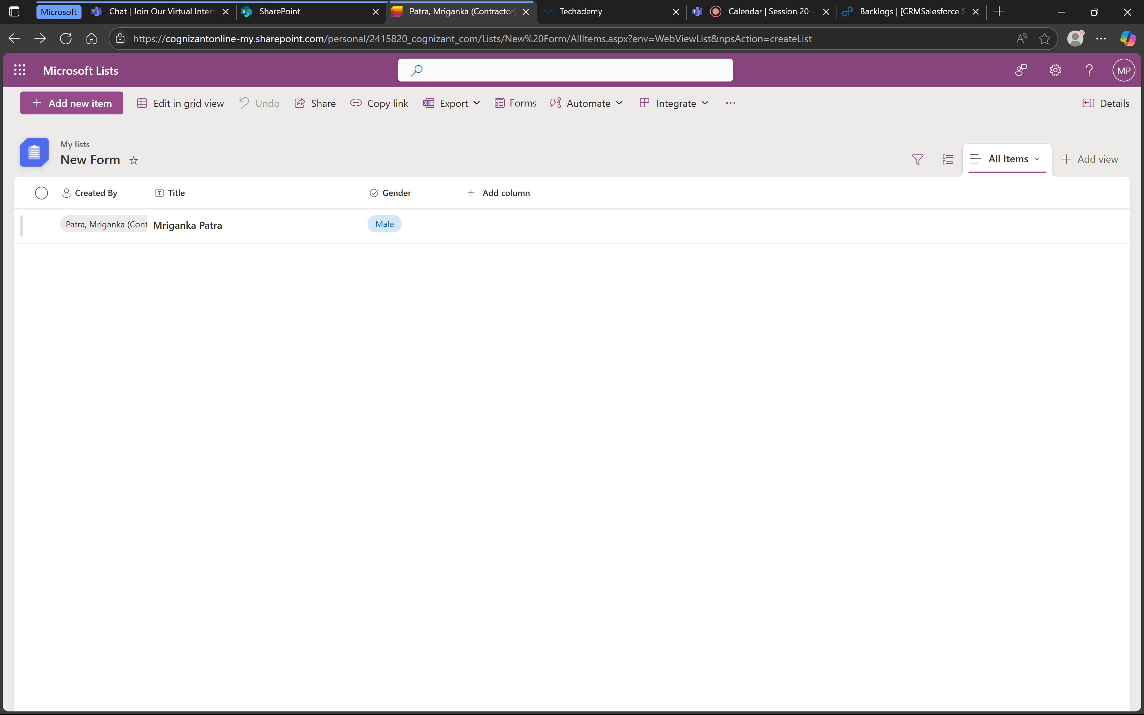

1. That means the form does not store values after cancellation and is working as expected.

Under epic > task created and assigned (703)

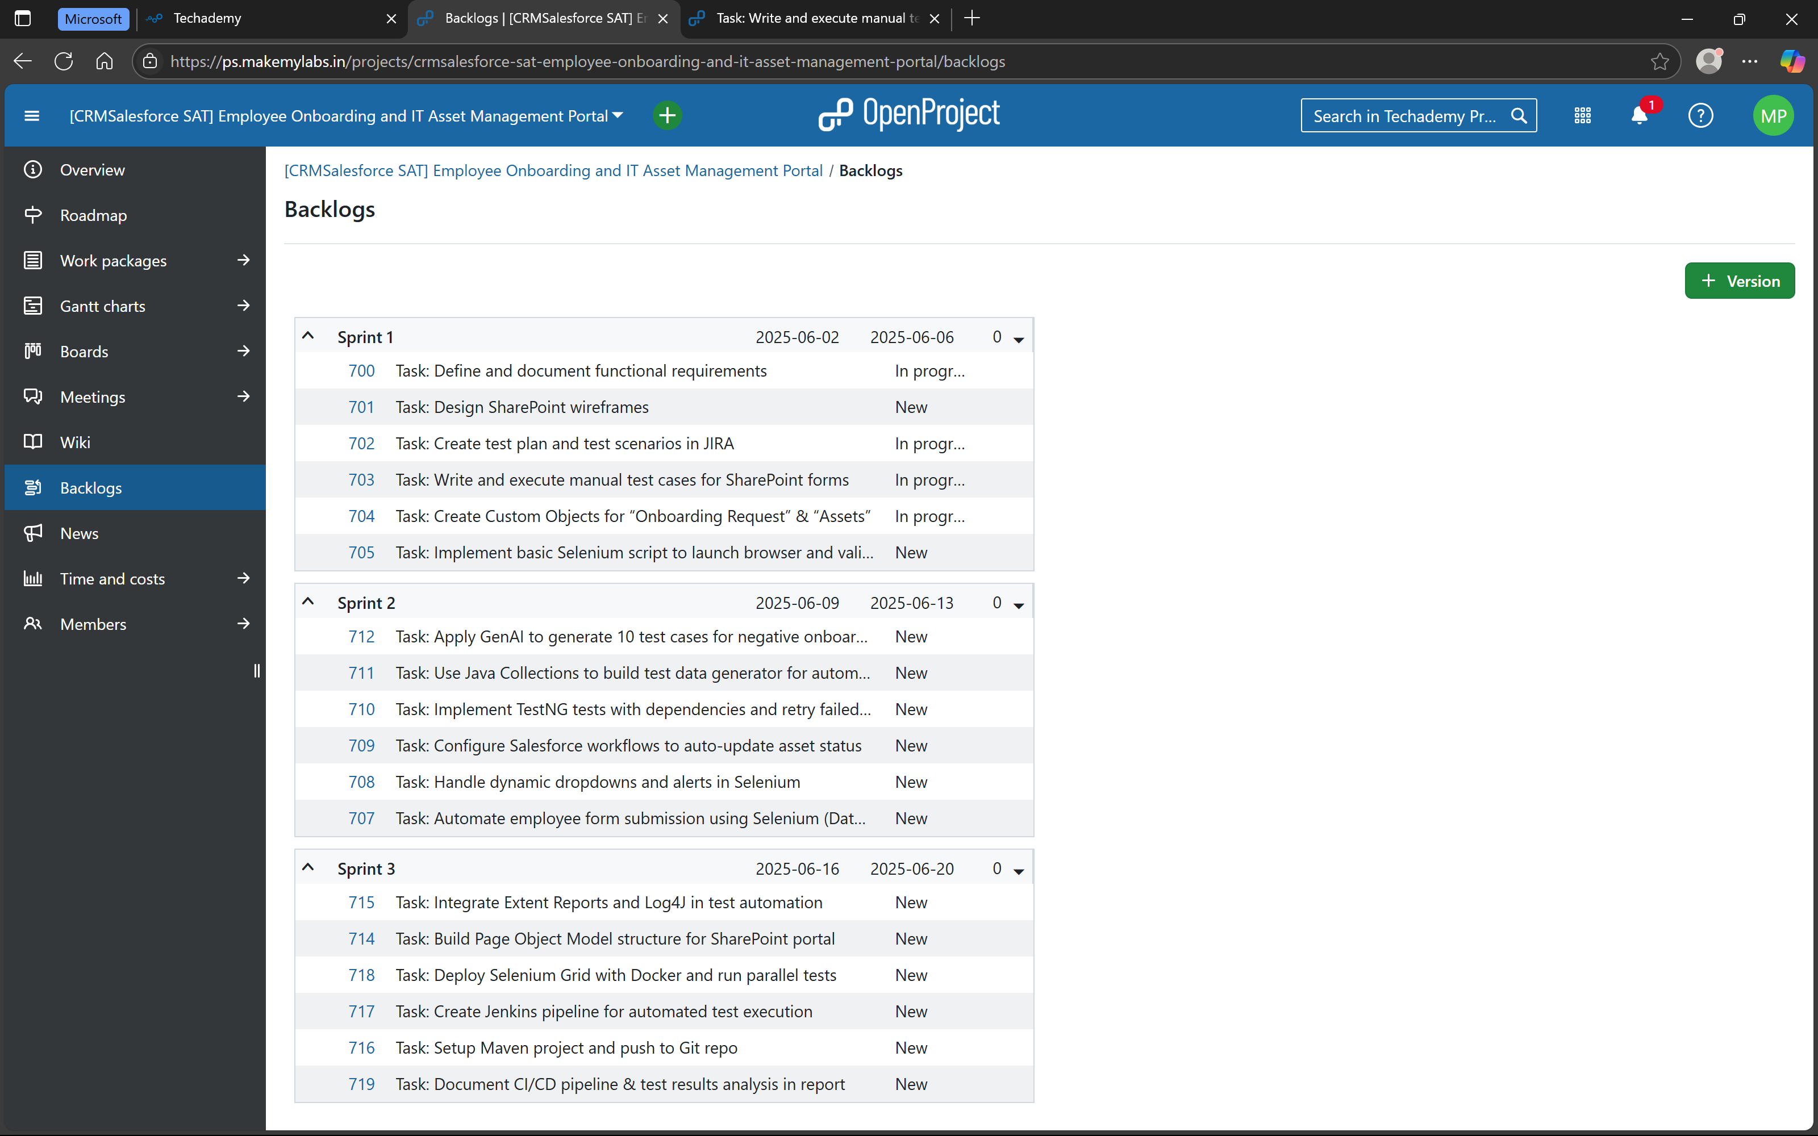

Under Task > user stories created and completed (with hierarchy)

